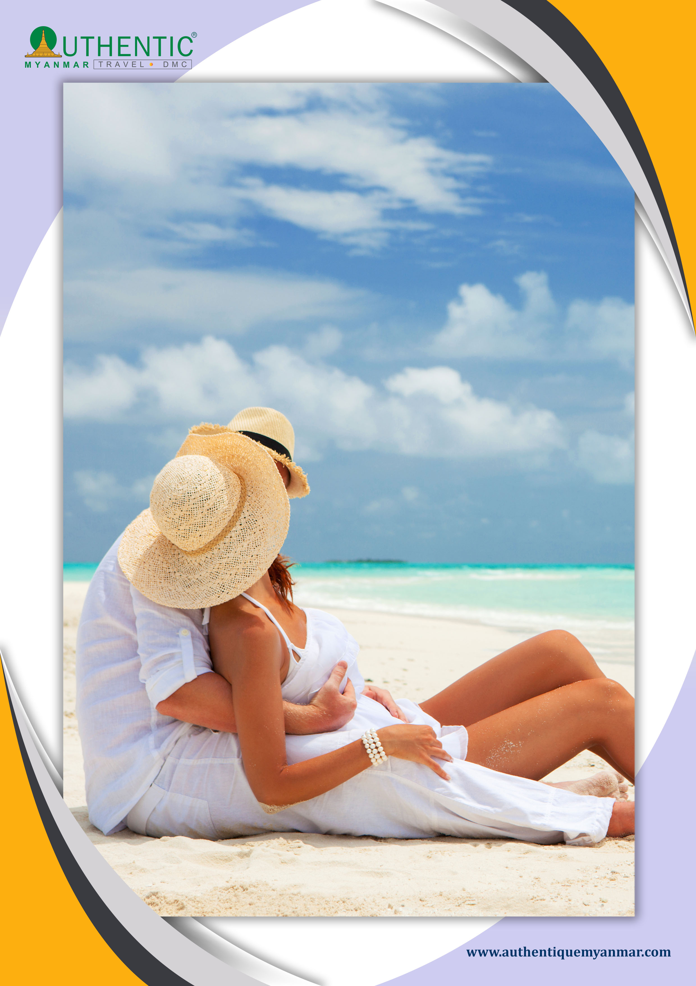
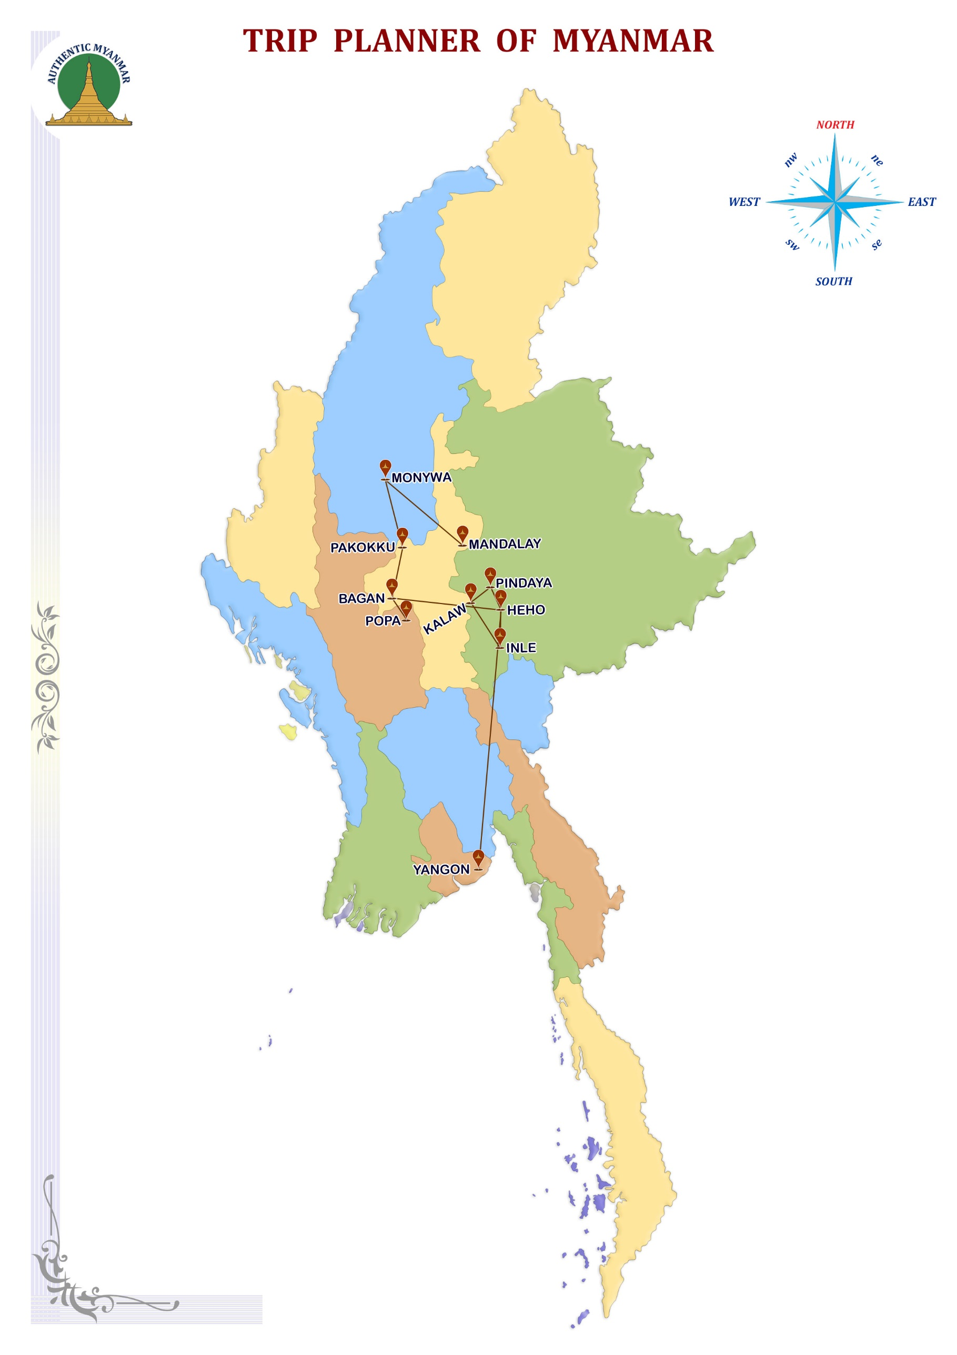
Burma occupies the most Western part of Asia, formed by the long North-South valley of Irrawaddy. You will be able to discover Yangon and Mandalay, the cities with the miles pagodas, you will find the forgotten temples of Bagan, and the area of the Lake Inle will be with you.

ITINERARY AT A GLANCE

DAY | DEPART | TRANSFER | VISIT | ARRIVE | RANK
DAY-01 | BANGKOK |  |  | MANDALAY | ***
DAY-02 | MANDALAY | / | MGN/SGN//AVA | MANDALAY | ***
DAY-03 | MANDALAY |  | POWIN TAUNG | MONYWA | ***
DAY-04 | MONYWA | / | PAKKOKU | BAGAN | ***
DAY-05 | BAGAN |  |  | BAGAN | ***
DAY-06 | BAGAN |  | POPA | BAGAN | ***
DAY-07 | BAGAN | - / | HEHO/PINDAYA | KALAW | **
DAY-08 | KALAW | - / | NYAUNG SHWE | INLE | ***
DAY-09 | INLE |  | INDEIN | INLE | ***
DAY-10 | INLE | - / | HEHO | YANGON | ***
DAY-11 | YANGON |  |  | YANGON | ***
DAY-12 | YANGON | - / |  | BANGKOK/ ?

Photo description is "The happy Honeymooners".

DAY 01 - BANGKOK OR OTHER DESTINATION – -MANDALAY

Welcomed by our guide and transfer to hotel and leisure.
Departure for Amarapura and continue to the 200- years –old U Bein Bridge, built-in 1782 at the time of Amarapura was the royal capital, entirely constructed of teak wood. In the afternoon, visits with the Shwenandaw monastery (or Golden Palace monastery) a superb example of traditional work, and Kuthodaw Pagoda, the world’s largest book, consisting of 729 marble slabs engraved with Buddhist scriptures.
Meals free.
Overnight at the hotel.

DAY 02– MANDALAY –- MINGUN –- SAGAING--AVA-MANDALAY

Breakfast at the hotel.
Weather permitting, visit the small market near the train station. The last train from the suburbs of Mandalay arrives around 10:30. You can enjoy the scenes of daily life with the vegetable merchants and locals who shop. It is a fascinating and accessible place. An excursion by boat on the Ayeyarwaddy River will take you to Mingun (45min approximately). Visit one of the world largest bells, weighing 90 tons MingunBell, HsinbyumePaya and the unfinished MingunPaya, built as one of the largest Saudis by King Bodawpaya. Return by boat to Mandalay. Upon arrival, proceed to Sagaing, a retreat for Buddhist devotees, to enjoy a magnificent view over the surrounding area. Then stop with the Pagoda Soon UPonnya Shin to benefit from the panorama. Continue a visit to the former royal capital of Ava, reached by a short boat trip. Visits by horse-drawn carriage to the Nanmyint Watch Tower, the remains of the palace building nicknamed “leaning tower of Ava”, MahaAungmye beautiful monastery built of brick and stucco and Bagayar Monastery, famous for its impressive ornate woodcarvings and teak posts. Return to Mandalay.
Meals free.
Overnight at the hotel.

DAY 03 - MANDALAY--MONYWA - PO WIN TAUNG –- MONYWA

After breakfast at the hotel, drive to Monywa (3h approximately) by coach.
Stop on route to visit the KaungMudaw Pagoda with its enormous white dome and its some 800 stone pillars located at the base. Visit multicoloured Thanboddhay temple, built from the dream designs of a noted monk.
Depart from the splendid temple-caves of PoWinTaung (1hr), a seldom-visited complex of cave temples and shrines (some dating back to the 15th century) that contain an abundance of Buddha images and some beautiful mural paintings. Moreover, continue to discover the maze of temples Shwe Ba Taung. Return to Monywa.
Meals free.
Overnight at the hotel.

DAY 04 - MONYWA –- PAKKOKU --CRUISING ON THE IRRAWADDY – BAGAN

Breakfast.
Drive to Pakkoku (3h approximately) by coach.
Then cruise to Bagan (2h 30), the occasion to discover the life of the banks of the river with its market gardening’s and its traditional villages of another time. Arrival in Bagan at the beginning of the afternoon.

Bagan is, without doubt, most astonishing site of Myanmar if it is all South East Asia. At the edges of Irrawaddy river, renamed from now on Ayeryarwaddy, and on the area of 40 km2 straighten up some hundreds of temples (2219 exactly). All of these remnants have been constructed of 11^{century} to 13 ^{century} by the sovereigns' successive who made the size of Bagan (Anawratha, Kyanzittha, Alaungsitthu and Narapatissithu,). This unbelievable concentration made of Bagan intense moment of your stay in Myanmar and the sunset of the site reminds an unforgettable moment.

Departure for BAGAN to discover of the 11th-century archaeological site. Visit stops at one of the pagodas where you can sit for the beautiful sunset. Meals free.
Overnight at the hotel.

DAY 05 – BAGAN

Breakfast.
Day devoted to discovering of Bagan "the mystic" extraordinary archaeological site which does not have anything to envy that of Angkor with its 3000 temples and pilot pink brick stupas of the apogee of the Buddhist architecture of Myanmar. Starting a sightseeing tour with a diverse selection of the most important pagodas and temples such as Shwezigon Pagoda, built by King Anawrahta in the early 11th century, and discovered temples Shwegugyi, Gawdawpalin and coloured market located in Old Bagan. We will meet the religious tradition of donating food and materials for the monks of the surrounding monasteries. Near the Law Ka Nanda pagoda, we will witness the great procession of monks coming out of the monastery to accept the offering of the local population. The locals meet together in a gesture of prayer to receive a blessing from the monks. You can join the local community to offer our material donations to the monks. Visit Ananda Temple, with its four substantial standing-Buddha images and numerous seated figures that arrange around the interior gallery and Gu Byauk Gyi Temple (under the protection of UNESCO), noted for its ancient mural paintings. Observe a sunset in the vicinity of Bagan’s ancient monuments.
Meals free.
Overnight at the hotel.

DAY 06 - BAGAN -- MONT POPA -- BAGAN

Breakfast at the hotel.
Your visit continues in Bagan with the discovery of the ruins of the Royal Palace, the discovery of the ruins of the Royal Palace; Tharaba's Gate, the temple of TayokPye. Visit a lacquer craftsmen’s workshop in the nearby Myinkaba village. Then, a 45 km drive (1 ½ hour) will take you to Mount Popa. An extinct volcano with spectacular views. It's a shrine dedicated to animist spirits knows as "Nats", and you will have time to climb nearly 800 steps to the shrine at the top of the peak. Return to Bagan. Meals free.
Overnight at the hotel.

DAY 07 - BAGAN –- HEHO--PINDAYA--KALAW

Breakfast.
Transfer to Nyaung U airport for domestic flight to Heho.
You are departing from the road (2h30 approximately) for Pindaya's cave, an impressively long way up into the hills and across the Shan Plateau, through fields of mountain rice.

Pindaya is especially famous for its natural caves in which ones were stored, with the passing of the centuries the donations of the pilgrims is more than 8000 statues of Buddha out of wood, alabaster, marble, cement. An occasion to discover the evolution that knew the representations of the Buddha through the time.

Visit magnificent Pindaya cave set in a limestone ridge overlooking a picturesque lake, where thousands of different types of Buddha images are a display in the various cave chambers. Continue to visit some local houses where families produce Shan paper and parasols.
Drive-by road to Kalaw. Meals free.
Overnight at the hotel.

DAY 08 – KALAW--INLE LAKE

Breakfast.
Departure by road (2h 30), for NyaungShwe, at the edge of the lake Inlé. Visit monastery out of wooden of Shwe Yan Pyay. Visit NyaungShwe. Visit Pagoda PhaungDawOo, one of the most sacred shrines in Myanmar, dating back to the 18th century, and visits some of its many artisan factories of weaving of silk, cigars, etc. Return to the dugout to the setting sunset. Meals free.
Overnight at the hotel.

DAY 09 – INLE LAKE-INDEIN

Breakfast.
The idyllic framework blotted around the mountains, and the Inle Lake is a punctuated blue oasis of villages on pile, temples and monasteries. You can discover the life of the lake: it's surprising floating vegetable gardens, fixed on the bottom of the lake by large piles of bamboo; its fishermen into, principal ethnic of the lake, which ancestral mode of fishing, with a bow net and while rowing with a leg, is unique in the world.
You can walk in the village and visit the old pagodas which built in the 12th century.

In Dein is located on the southwestern bank of the principal lake. In then close it village one can say that it is the most picturesque part of the Inle lake. The brook which leads to the village animate with various activities on its banks. In-Dein village is used as a main door to approach the western part of the lake and to discover the close villages situated on the hills.

Visit monastery NgaPhe, also called "monastery of the jumping cats" since its monks drew up cats to jump inside the rings. This monastery out of wood, built on piles, and contains an astonishing collection of statues of Buddha. Enjoy the canoe-kayak ride to admire the beautiful surrounding landscape surrounding Inle Lake and the culture of the local people of this region. This small boat trip will offer you a quieter sailing experience, rowed and guided by the ladies of the "Inthar" ethnic group.
Return to the dugout to the setting sunset. Meals free.
Overnight at the hotel.

DAY 10 - INLE LAKE --HEHO–- YANGON

Breakfast at the hotel.
Transfer by the road to the Heho airport and fly back to Yangon.
Visit colonial quarter such as Maharbandula Garden, City Hall, High court, etc.
In the colonial district, discover the administrative buildings "The Secretariats" of the east wing and its interior courtyard of this colonial building. You can dive back into the 1950s and its magnificent architectural treasure. Then walk through Chinatown home, along with colonial buildings are crumbling facades, an abundance of small shops, hawkers and street canteens. Visit of the Bogyoke market, market lacquer, precious stones, fabrics. Free time for your last minute shopping. Meals free.
Overnight at the hotel.

DAY 11 - YANGON

Breakfast at the hotel.
Take the circular train to observe the daily life of Yangon.
The bus will be waiting at Insein market. Visit Chaukhtetgyi pagoda and of its great Buddha laying whose colossal stature is fortunately softened by the good-naturalness of its expression! Visit the Shwedagon pagoda, one of the world’s most spectacular religious monuments, will conclude the tour of this pictures garden city. The golden dome of the Shwedagon Pagoda rises 98 meters.
Meals free.
Overnight at the hotel.

DAY 12 - YANGON –-BANGKOK OR OTHER DESTINATION

Breakfast.
Leisure time until the transfer to the airport.
Transfer to the international airport, take-off bound for Bangkok.

END OF SERVICE

