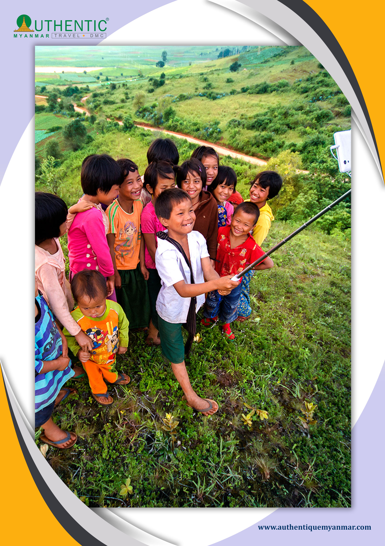
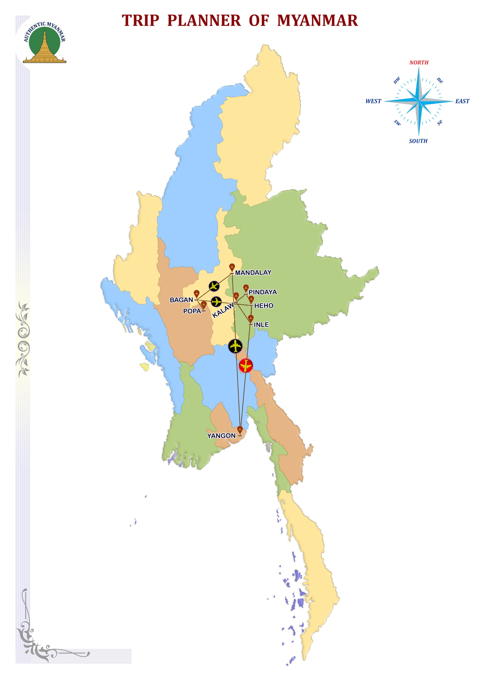
Burma occupies the most Western part of Asia, formed by the long North-South valley of Irrawaddy. You will be able to discover Yangon and Mandalay, the cities with the miles pagodas, and you will discover the forgotten temples of Bagan, and bewitch by the area of the Inle lake.

ITINERARY AT A GLANCE

DAY | DEPART | TRANSFER | VISIT | ARRIVE | RANK
DAY-00 | FRANCE |  |  | BANGKOK
DAY-01 | BANGKOK | / |  | YANGON | ***
DAY-02 | YANGON |  |  | KYAIKHTIYO | ***
DAY-03 | KYAIKHTIYO |  |  | YANGON | ***
DAY-04 | YANGON | / |  | BAGAN | ***
DAY-05 | BAGAN |  |  | BAGAN | ***
DAY-06 | BAGAN |  | POPA | BAGAN | ***
DAY-07 | BAGAN | / | SGN/AVA | MANDALAY | ***
DAY-08 | MANDALAY |  | AMA | MANDALAY | ***
DAY-09 | MANDALAY | / | MINGUN | MANDALAY | ***
DAY-10 | MANDALAY | / |  | KYAING TONG | ***
DAY-11 | KYAING TONG |  |  | KYAING TONG | ***
DAY-12 | KYAING TONG |  |  | KYAING TONG | ***
DAY-13 | KYAING TONG | / | HEHO | INLE | ***
DAY-14 | INLE |  |  | INDEIN | ***
DAY-15 | INLE | / | HEHO | YANGON | ***
DAY-16 | YANGON | / |  | BANGKOK | ***

SEA LEVEL

INLE: 885 M

Photo description: "Maha Thetkya Thiha Pagoda in Ava."
Bodaw Paya's grandson built maha Thakya Thiha Pagoda King Bagyidaw of Yadanapura Innwa with the use of 26723 visses of five kinds of metals namely gold silver bronze iron and zinc in the year 1188 in his 19th year of reign.

DAY 01 - BANGKOK OR OTHER DESTINATION – -YANGON

Welcomed by our guide and transfer to hotel and leisure. Green city marked out lakes with the carefully landscaped banks, Yangon dissimulates under its peaceful airs a vibrating animation. Visit Chaukhtetgyi pagoda and of its great Buddha laying whose colossal stature is fortunately softened by the good-naturalness of its expression! Lunch at a local restaurant. After lunch, an extended visit to the Shwedagon pagoda, one of the world’s most spectacular religious monuments, will conclude the tour of this pictures garden city. The golden dome of the Shwedagon Pagoda rises 98 meters.
Dinner and overnight at hotel.

DAY 02 - YANGON–- KYAIKHTIYO

Breakfast.
Depart to Kyaikhtiyo, one of Myanmar’s landmarks, famous for its precious position and religious importance. Arrival at base camp and assistance to board the trucks that climb the mountain to Yathae Taung. Departure to go Kyaikhtiyo pagoda with the cable car. Lunch at restaurant.
“The head of the Hermit" is an enormous rock gilded with the sheet and a miracle of balance.
Burmese story says because of the hair of the Buddha, which is powerful, this rock in the overhand held in surplus where the pagoda built on it's top. A long time of difficult access, trucks make it possible from now to climb, supplemented by a short, easy walk.
Dinner and overnight at hotel.

DAY 03 - KYAIK HTI YO --BAGO--YANGON

Breakfast.
Departure to BAGO. Full day excursion to the former capital of Pegu (Bego).She was founded in 573 by two princes of Thaton. Lunch at a local restaurant. Legend has it that he saw, on an island in the middle of a lake, a goose on the back of a gander, they saw a favourable to found the royal capital omen. Impressive are the 55 meters reclining Buddha, Shwethalyaung. This Pagoda is the "paid the great golden god", one of the most revered of Burma. It's golden dome stands out clearly in the blue sky, dominates his full height throughout the city that disappears in a mass of greenery. Back to Yangon. Arrive in Yangon.
Dinner at a local restaurant.
Overnight at the hotel.

DAY 04 - YANGON--BAGAN

Breakfast.
Transfer to Yangon airport for domestic flight to Nyaung U.
Day devoted to discovering of Bagan "the mystic" extraordinary archaeological site which does not have anything to envy that of Angkor with its 3000 temples and pilot pink brick stupas of the apogee of the Buddhist architecture of Myanmar. Starting a sightseeing tour with a diverse selection of the most important pagodas and temples such as ShwezigonPagoda, built by King Anawrahta in the early 11th century, and discovered temples Shwegugyi, Gawdawpalin and coloured market located in Old Bagan. Afterwards, lunch at a local restaurant. Visit Ananda Temple, with its four substantial standing-Buddha images and numerous seated figures that arrange around the interior gallery and Gu Byauk Gyi Temple (under the protection of UNESCO), noted for its ancient mural paintings. Observe a sunset in the vicinity of Bagan’s ancient monuments.
Dinner and overnight at hotel.

DAY 05 - BAGAN

Breakfast.
Continuation of the visits of Bagan with the discovery of the ruins of the Royal Palace; door of Tharaba, temple of Tayok Pye. Visit of a lacquer craftsmen’s workshop in nearby Myinkaba village. After lunch at local restaurant, continuation of the Bagan visits. We will meet the religious tradition of donating food and materials for the monks of the surrounding monasteries. Near the Law Ka Nanda pagoda, we will witness the great procession of monks coming out of the monastery to accept the offering of the local population. The locals meet together in a gesture of prayer to receive a blessing from the monks. You can join the local community to offer our material donations to the monks. Dinner at a local restaurant.
Overnight at the hotel.

DAY 06 - BAGAN -- MONT POPA -- BAGAN

Breakfast at the hotel.
Then, a 45 km drive (1 ½ hour) will take you to MountPopa. An extinct volcano with spectacular views. (Note: The restaurant of the Mount Popa offers a magnificent view over the whole site Mount Popa and for clients who cannot climb on Mount Popa will allow them to enjoy the unique landscape from the terrace of the restaurant). Lunch takes at the Popa Mountain Resort Hotel Its shrine dedicated to animist spirits knows as "Nats", and you will have time to climb nearly 800 steps to the shrine at the top of the peak. Return to Bagan.
Dinner at a local restaurant.
Overnight at the hotel.

DAY 07 - BAGAN--MANDALAY- SAGAING- AVA -MANDALAY

Breakfast.
Transfer to Nyaung U airport for domestic flight to Mandalay.
Upon arrival, proceed to Sagaing, a retreat for Buddhist devotees, to enjoy a magnificent view over the surrounding area. Then stop with the Pagoda Soon UPonnya Shin to benefit from the panorama.
Lunch at a local restaurant. After lunch, continue a visit to the former royal capital of Ava, reached by a short boat trip. Visits by horse-drawn carriage to the Nanmyint Watch Tower, the remains of the palace building nicknamed “leaning tower of Ava”, MahaAungmye beautiful monastery built of brick and stucco and Bagayar Monastery, famous for its impressive ornate woodcarvings and teak posts. Return to Mandalay.
Dinner and overnight at hotel.

DAY 08 - MANDALAY- AMARAPURA-MANDALAY

Breakfast.
Weather permitting, visit the small market near the train station. The last train from the suburbs of Mandalay arrives around 10:30. You can enjoy the scenes of daily life with the vegetable merchants and locals who shop. It is a fascinating and accessible place. Departure for Amarapura and continue to the 200- years –old U Bein Bridge, built-in 1782 at the time of Amarapura was the royal capital, entirely constructed of teak wood. Discover of the unique monastic Maha Gandayon. Return to Mandalay. Visit the Mahamuni Pagoda. Visit large Zegyo market and workshops of tapestry and weaving.
Lunch at local restaurant. During the festival of the pagoda at the beginning of February of the thousands of faithful come from the neighbouring districts to cover the Buddha with gold leaves. After the visit, walk in the district of the marble sculptors.
Dinner at local restaurant.
Overnight at hotel.

DAY 09 – MANDALAY –- MINGUN –- MANDALAY

Breakfast at the hotel.
An excursion by boat on the Ayeyarwaddy River will take you toMingun (45min approximately). Visit one of the world largest bells, weighing 90 tons MingunBell, Hsinbyume Paya and the unfinished MingunPaya, built as one of the largest Saudis by King Bodawpaya. Return by boat to Mandalay.
Lunch on the boat during the visit. In the afternoon, visits with the Shwenandaw monastery (or Golden Palace monastery) a superb example of a traditional work, and KuthodawPagoda, the world’s largest book, consisting of 729 marble slabs engraved with Buddhist scriptures. Dinner at a local restaurant.
Overnight at the hotel.

DAY 10 - MANDALAY--KENGTUNG

Breakfast at the hotel.
Transfer to Mandalay airport for domestic flight to Kyaing Tong, the former Shan capital. Arrive, Kyaing Tong, transfer to hotel. Lunch at a local restaurant. Start sightseeing tour with MahaMyat Muni Pagoda, housing Mandalay style Buddha image and nearby a monastery where the monks learn "Khun" language, which is very similar to use in Northern Thailand.
Dinner and overnight at hotel.

DAY 11 -KENTUNG--PINTAUK--KENGTUNG

Breakfast at the hotel.
After breakfast, start for a hiking tour into the Pin Tauk area. Lush mixed monsoon forest with a view to the open rice fields looking like a vast, green patchwork blanket shimmering in the water of the flooded paddy fields. The local stationed guide will introduce you to the villagers of Aka and A tribes. Some baptize, some tribes still animists. On the way, our guides will serve you the picnic lunch. Some of the Ann villages or on hills, approximately 45% "steep" walk-up but for not more than half an hour. The Ann people, known to be the kindest tribe, as there is no case up to nowadays where an Ann member has ever been violent. It will take about 6 hours to visit the villages, including visits to the houses. Late afternoon comes back to Kyaing Tong.
Dinner and overnight at hotel.

DAY 12 – KENTUNG--HO KYIN--KENGTUNG

Wake up early in the morning and breakfast at the hotel.
Then drive to Ho Kyin (appr. 1½ hr drive). Visit Hokyin village with Akha tribes, still wearing traditional costumes with silver coils. If an Akhar woman wants to have her full dress, it will take about more than one hour. Picnic lunch on the way. Then walk to nearby three villages of Akha tribes to see their daily life in those rural areas. The walk is not difficult and can make slowly. In the late afternoon, back to Kyaing Tong.
Dinner and overnight at hotel.

DAY 13 – KYAING TONG–-HEHO-- INLE LAKE

Breakfast at the hotel.
Drive to Kyaing Tong airport for domestic flight to Heho.
Drive-by road to Nyaung Shwe. Lunch at a local restaurant.
Departure by road (2h 30), for NyaungShwe, at the edge of the lake Inlé. Visit monastery out of wooden of Shwe Yan Pyay. Visit of NyaungShwe. Boarding on boat to go to Hotel. Free time in the afternoon.
Enjoy the canoe-kayak ride to admire the beautiful surrounding landscape surrounding Inle Lake and the culture of the local people of this region. This small boat trip will offer you a quieter sailing experience, rowed and guided by the ladies of the "Inthar" ethnic group.
Dinner and overnight at hotel.

DAY 14 – INLE LAKE--INDEIN

Breakfast at the hotel.
The idyllic framework blotted around the mountains, and the Inle Lake is a punctuated blue oasis of villages on pile, temples and monasteries. You can discover the life of the lake: it's surprising floating vegetable gardens, fixed on the bottom of the lake by large piles of bamboo; its fishermen into, principal ethnic of the lake, which ancestral mode of fishing, with a bow net and while rowing with a leg, is unique in the world.
You can walk in the village and visit the old pagodas which built in the 12th century.
Lunch at a local restaurant.

Inn Dein locates on the southwestern bank of Inle lake. Its village one can say that it is the most picturesque part of the Inle lake. The brook which leads to the lively village with various activities on its banks. In-Dein village is used as the main door to approach the western part of the lake and to discover the close villages situated on the hills.

After lunch, visit monastery NgaPhe, also called “monastery of the jumping cats” since its monks drew up cats to be jumped inside rings. This monastery out of wooden, built on pile, and contains an astonishing collection of statues of Buddha. Visit Pagoda PhaungDawOo, one of the most sacred shrines in Myanmar, dating back to the 18th century, and visits some of its many artisan factories of weaving of silk, cigars, etc.
Return to the dugout to the setting sunset.
Dinner and overnight at hotel.

DAY 15 - INLE LAKE--HEHO–- YANGON

Breakfast at hotel.
Transfer by the road to Heho airport and fly back to Yangon.
Visit colonial quarter such as Maharbandula Garden, City Hall, High court,etc.
Lunch at the local restaurant. In the colonial district, discover the administrative buildings "The Secretariats" of the east wing and its interior courtyard of this colonial building. You can dive back into the 1950s and its magnificent architectural treasure. Then walk through Chinatown home, along with colonial buildings are crumbling facades, an abundance of small shops, hawkers and street canteens. Visit the Bogyoke Market, market lacquer, precious stones, fabrics, etc. Free time for your last minute shopping.
Dinner at a local restaurant.
Overnight at the hotel.

DAY 16 - YANGON –-BANGKOK OR OTHER DESTINATION

Breakfast.
Leisure time until the transfer to the airport.
Transfer to the international airport, take-off bound for Bangkok.

END OF SERVICE

