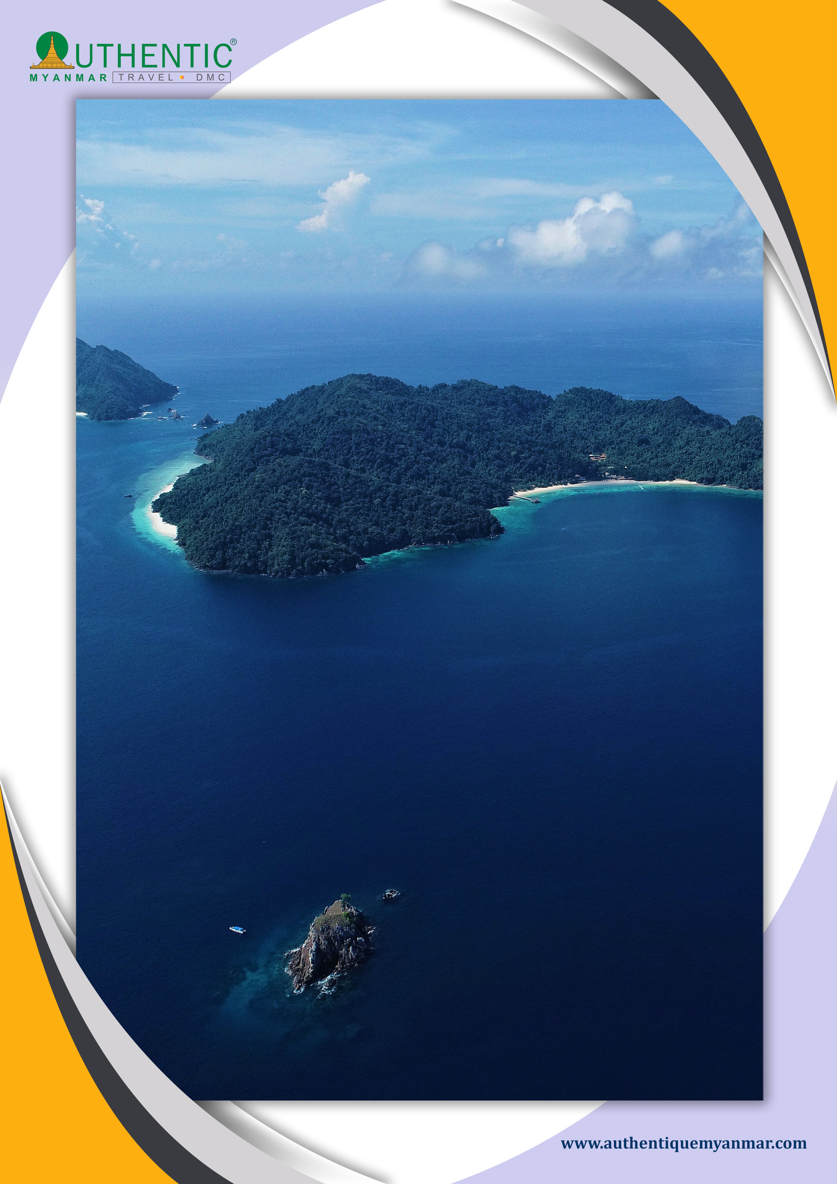
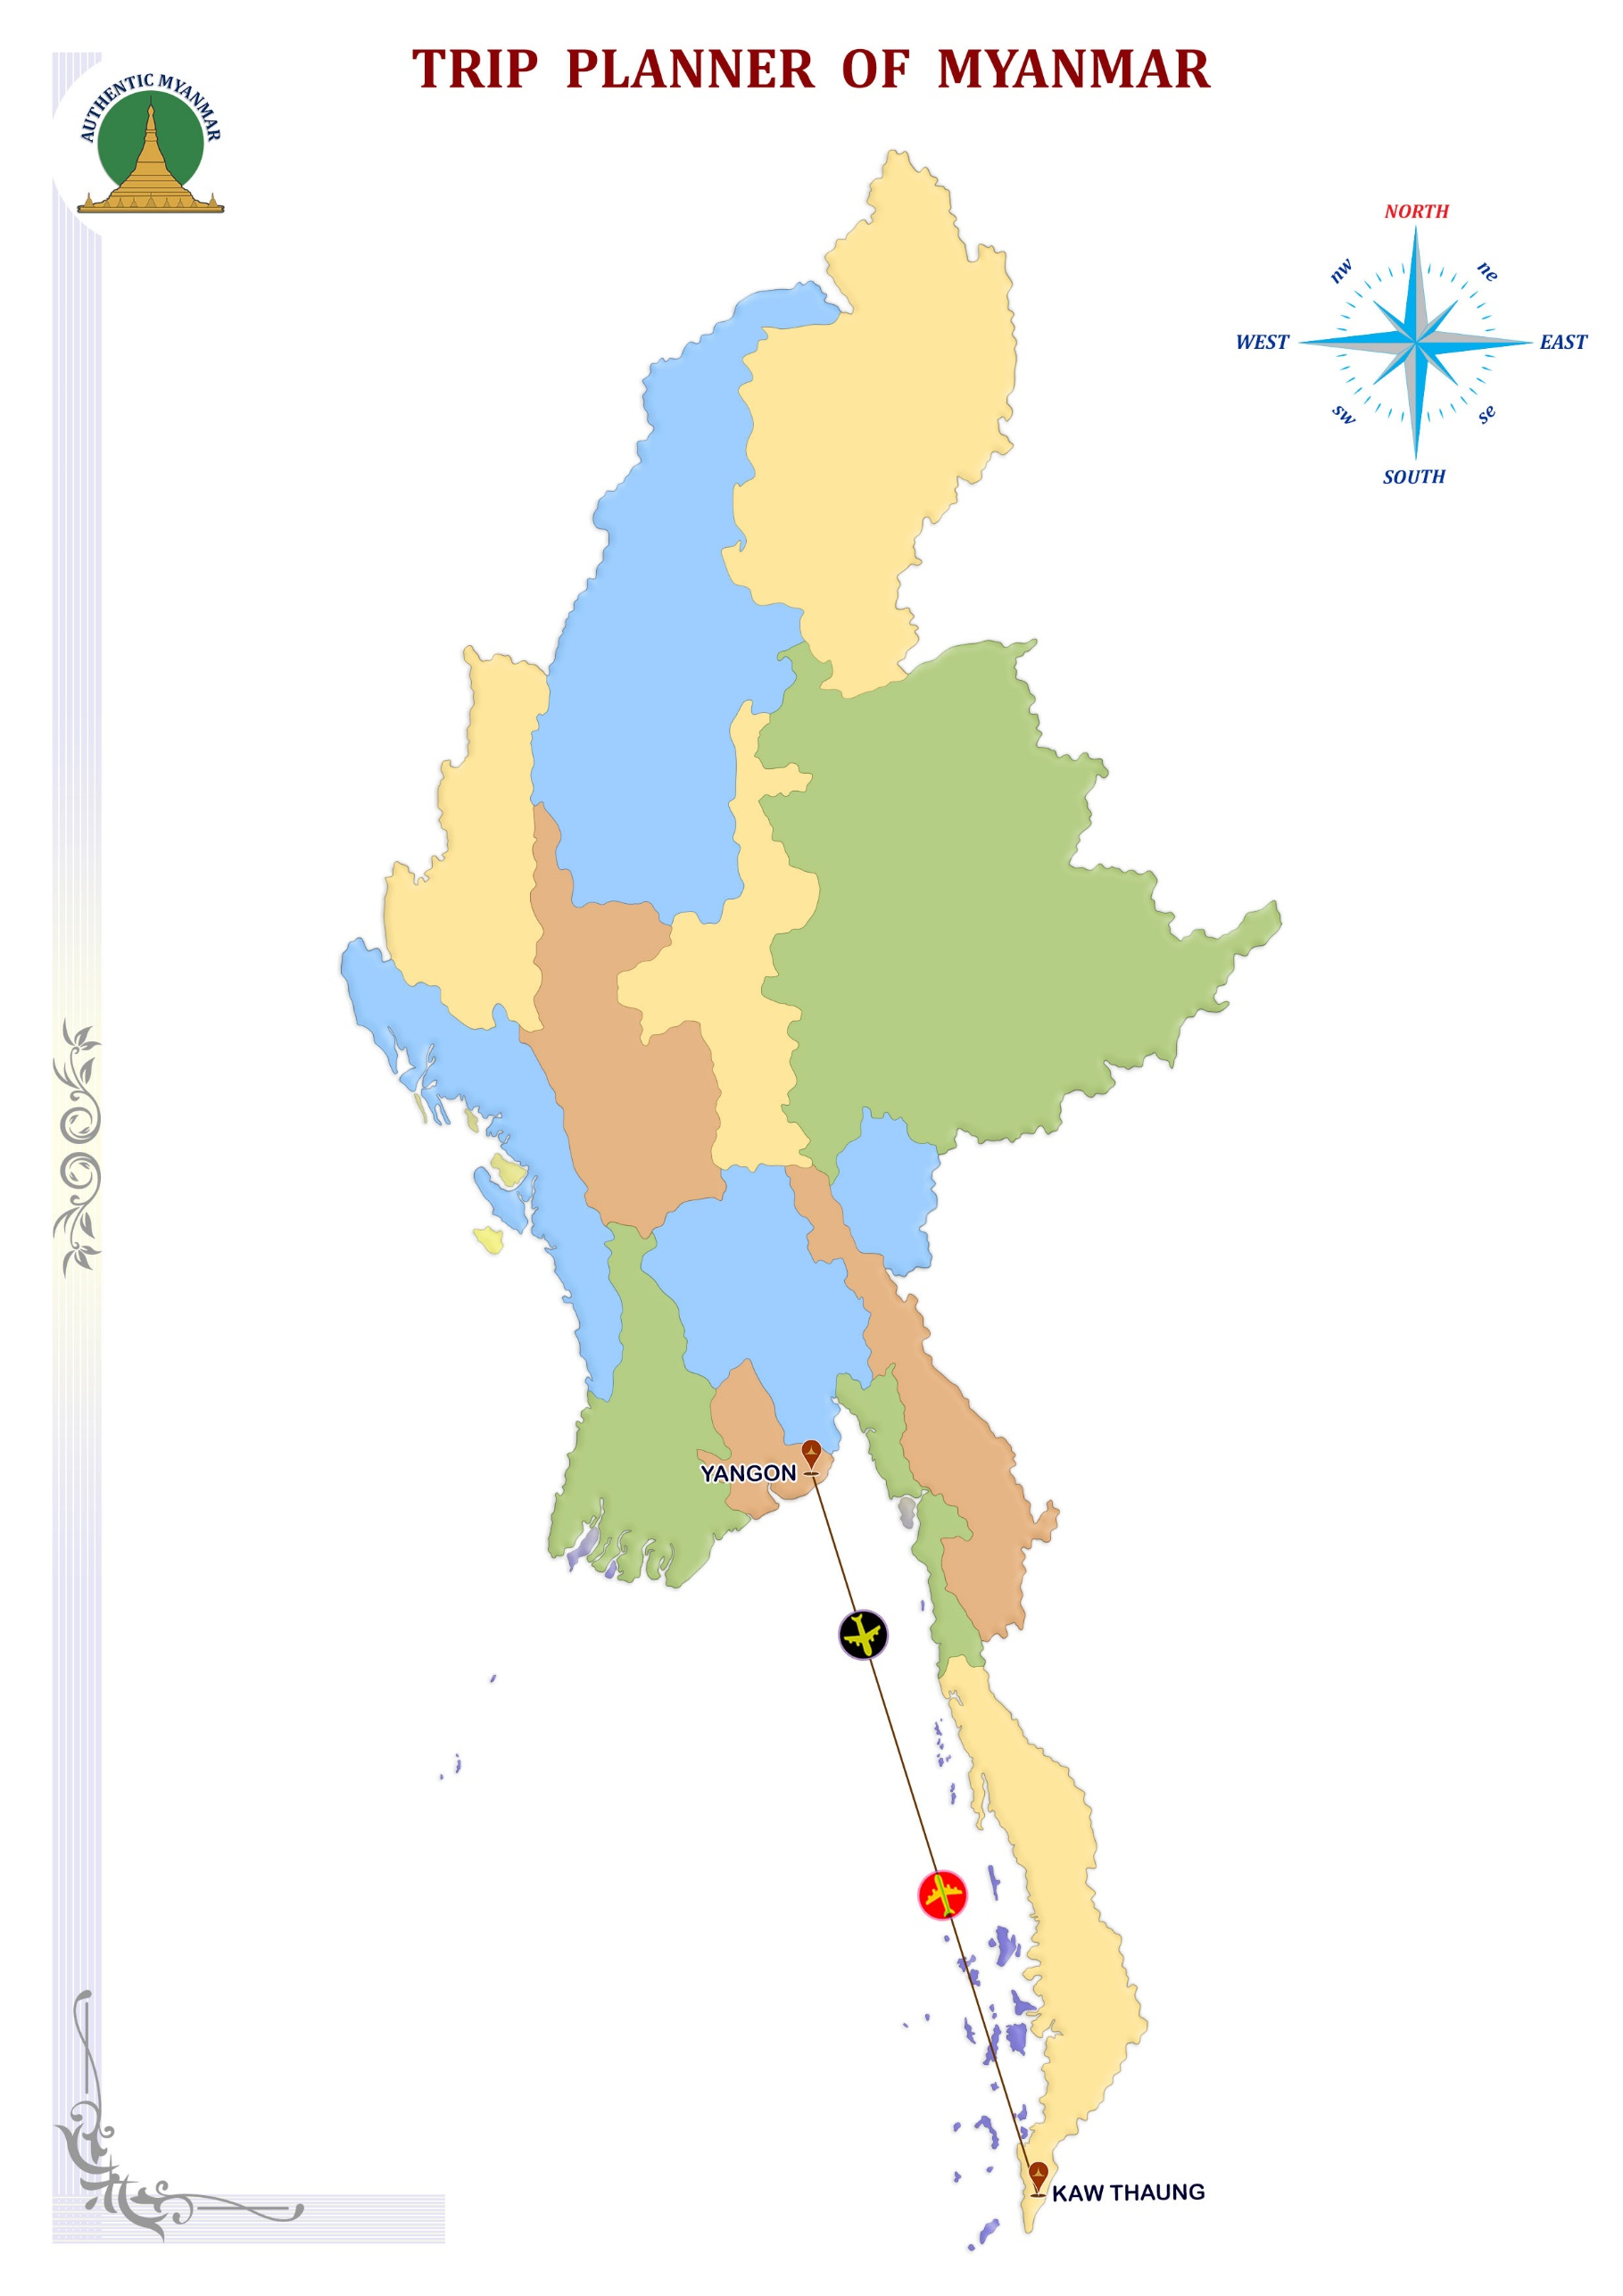

Myanmar: Myanmar’s Mergui Archipelago in the Andaman Sea (Burma) has over 800 tropical islands, covering an area of over 10,000 square kilometers. The archipelago was closed to the outside world more than 50 years until the end of 1996 countless uninhabited islands, virgin beaches, lakes and waterfalls. This is one of the few remaining untouched areas on Earth because of their isolation. The islands and surrounding seas are alive with amazing diversity of wildlife, young and old, hard corals, soft and huge sponges. The vast includes giant groupers, all kinds of fish aggregation, various species of sharks, regular observations of a large number of stingrays. The macro life is present; sea horses, pipefish and many more rare ghost are the inhabitants of the archipelagos.

ITINERARY AT A GLANCE

DAY | DEPART | TRANSFER | VISIT | ARRIVE | RANK
DAY-01 | YANGON |  |  | KAW THAUNG | ***
DAY-02 | KAWTHAUNG | 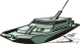 |  | SAY TAN ISLAND | ***
DAY-03 | SAY TAN ISLAND |  |  | WESTERN ROCKY | ***
DAY-04 | WESTERN ROCKY |  |  | BOULDER ISLAND | ***
DAY-05 | BOULDER ISLAND |  |  | BO WEI ISLAND | ***
DAY-06 | BO WEI ISLAND |  |  | SALET GALET | ***
DAY-07 | SALET GALET |  |  | ISLAND 115 | ***
DAY-08 | ISLAND 115 |  |  | KAWTHAUNG | ***

Photo description: horse Shoe Island and Cocks Comb Island from Kawthaung.

DAY 01 - KAWTHAUNG
Upon arrival in Kawthaung, check in and take a land tour to temples, local wares and the markets.
Enjoy dinner and the first night aboard SY Dallinghoo, along the bustling border town of Kawthaung.

DAY 02 – KAWTHAUNG--SAY TAN ISLAND

Upon daybreak, we set sail 40 Nautical Miles to South Bay Zardet Kyee Island via Heart Lagoon (if the tides allow for kayaking into the enclosed Lagoon) and Say Tan Island. This is a day to settle down, visit beaches, kayak and get to know each other. Scuba-diving begins tomorrow.

DAY 03 – SAY TAN ISLAND--WESTERN ROCKY

An early start from the South Bay will take you to our first dive site, Western Rocky - a mid-ocean site with rocky outcrops piercing the surface. This is a great site where two dives can be organised. The second exciting dive site is at Fan Forrest Pinnacle, a mid-ocean sea mount which stands 6 meters above the water surface.

DAY 04 – WESTERN ROCKY--BOULDER ISLAND

Dive at Boulder Island where there are several diving sites and walking tracks. With an abundant wildlife above and below the water surface, diving, walking, kayaking and snorkelling are activities of the day on this pristine, well-protected tropical island.

DAY 05 – BOULDER ISLAND--BO WEI ISLAND

We depart for the first dive at the southern rocks of Bo Wei Island, following a short passage to Jar Lann Kyun Village and/or Kyun Pila East Bay. Jar Lann Kyun count a small village that houses a big temple, local shipyards and a busy fishing transfer port. This spot offers an opportunity to those wanting to experience the Mergui culture.

DAY 06 – BO WEI ISLAND--SALET GALET

A short passage takes us to one of the best dive sites in the Mergui Archipelago, named Three Islets. Following the dive, we will head to Salet Galet, a unique fishing village, to explore a beautiful mangrove river if the tide allows.

DAY 07 – SALET GALET--ISLAND 115

Departing early and 40 Nautical Miles south-bound, we head to Island 115 for lunch, swimming and snorkelling. A further 24 Nautical Miles to Barwell Passage will bring us to our final night anchorage in the Mergui.

DAY 08 – ISLAND 115--KAWTHAUNG

Setting sail on a 3-hour passage takes us back to Kawthaung. If time permits, take a swim and enjoy some beach time before departure if transfers allow it.

END OF SERVICE

