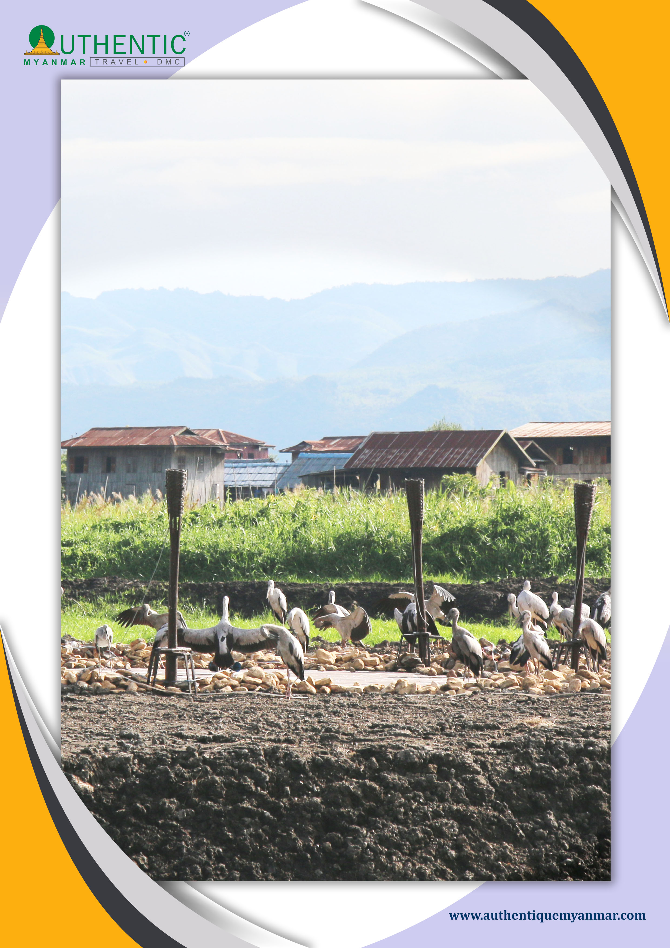

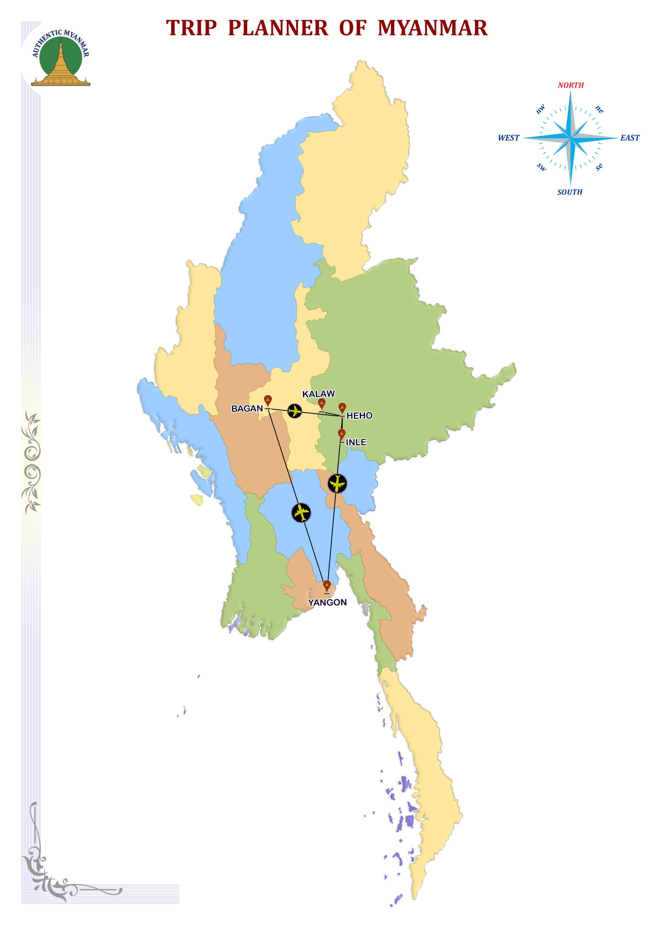

**All the tropical forests of Burma are home to a multitude of animal species. There are more than 1,000 bird species in Burma. This country serves as a refuge for all kinds of rare bird species, including migratory birds from all over Southeast Asia. While observing the numerous specimens of birds, you will be able to discover the Burmese tropical forest, as well as the mountain at high altitude, the forgotten temples of Bagan without forgetting the magnificent region of the Inle lake which serves as a resting place for migratory birds, (protected area)**

**ITINERARY AT A GLANCE**

|  |  |  |  |  |  |
| --- | --- | --- | --- | --- | --- |
| **DAY** | **DEPART** | **TRANSFER** | **VISIT** | **ARRIVE** | **RANK** |
| **DAY-01** | **BANGKOK** | **/**Aircraft Airplane Clip Art |  | YANGON | **\*\*\*** |
| DAY-02 | YANGON |  | HLAW GA | YANGON | **\*\*\*** |
| DAY-03 | YANGON | **/**Aircraft Airplane Clip Art |  | BAGAN | **\*\*\*** |
| DAY-04 | BAGAN |  |  | BAGAN | **\*\*\*** |
| DAY-05 | BAGAN | **/**Aircraft Airplane Clip Art | HEHO | KALAW | **\*\*** |
| DAY-06 | KALAW |  |  | KALAW | **\*\*** |
| DAY-07 | KALAW | **/** |  | INLE | **\*\*\*** |
| DAY-08 | INLE | **/**Aircraft Airplane Clip Art | HEHO | YANGON | **\*\*\*** |
| DAY-09 | YANGON | **/**Aircraft Airplane Clip Art |  | **BANGKOK/?** |  |

**DAY 01 - BANGKOK OR OTHER DESTINATION – Aircraft Airplane Clip Art-YANGON **

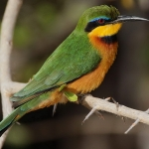  
Welcomed by our English guide and transfer to hotel and leisure.

Green city marked out lakes with the carefully landscaped banks, Yangon is full of vigour and vibrancy. Lunch at a local restaurant.

The visit begins by observing birds around the town of Yangon as **Prinia Little Grebe, Lesser Whistling Duck, Coppersmith Barbet, Bee-eaters, Little Cormorant, Tailorbird, Mynas, Bronze-winged**, **Oriental Darter, Moorhen, Bulbuls, Pheasant-tailed jacanas** and many other species can be met with during our trip.

Dinner and overnight at **hotel.**

**DAY 02 – YANGON--HLAW GA-YANGON **

Breakfast.

Road to the Wilderness Park **Hlaw Ga**.

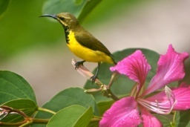Visit the Wildlife Park hlaw ga to go to meet the birds you can see species such as **Red-vented, Red-whiskered, Black-crested, Black-headed, Puff-throated & Chestnut-capped babblers, Scarlet-backed Flowerpecker Ruby-cheeked and other species of waterbird such as Spot-billed and Lesser Whistling Ducks, Oriental Darter, Little Ringed Plover** and other birds. **Black-naped Oriole, Osprey, Oriental Reed, Greenish and Yellow-browed Warbler Asian Openbill, Blue-tailed and Chestnut-headed Bee-eaters, Painted Stork, Spotted Redshank, Green, Olive-backed & Purple Sunbirds, Cotton Pygmy Goose and Black-naped Oriole**, you can also experience the winter birds like Racket-tailed Treepie, White-breasted Waterhen, Green-billed Malkoha, Stripe-throated with red eyes that we can meet just south of Burma, Greater Racket-tailed Drongos, Forest Wagtail, Red-wattled Lapwing, Lesser Racket-tailed near-endemic Streak-eared Bulbuls, White-crested necklaced Laughingthrushes & Lesser Black-winged Cuckooshrike very rare Pale-Capped Pigeon, Common Moorhen, White-rumped Shama, Red Junglefowl, although other species may be flush. Picnic lunch at the lake in the park or a small local restaurant.

Back to Yangon late afternoon. In the late afternoon, discover one of the pearls of Myanmar true emblem of the country, the **Shwedagon Pagoda.** You can walk to the sound of bells, and incantations of the faithful at the foot of the massive gold as the last rays of the sun ablaze with thousands of lights stupa.

At the hotel,overnight and the dinner.

**DAY 03 - YANGON-Aircraft Airplane Clip Art-BAGAN **

Breakfast.

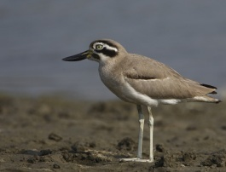Morning flight to **Bagan**.

Day dedicated to the discovery of Bagan, an extraordinary archaeological site that has Buddhist architecture Myanmar and birds of rare species. Transfer to the hotel to drop off luggage. Visit **Bagan cycling**. You will find in this area of endemic birds like **Burma Burmese Bushlark and white-throated Babbler.**

Lunch at a local restaurant. Downhill walk to the river and boarding of a local boat from which you can go to the meeting and the discovery of several bird species such as **Pied Kingfisher, Long-billed Pipit, Sand Lark, Indian Skimmer, River Lapwing, Great Thick-knee, Laggar Falcon, white-tailed Stonechat, Small Pratincole, of thousands In Plain & Sand Martins, River**

**& Black-bellied Terns, Spot-billed Duck, birds** and other spaces. You can also experience the winter birds like **Northern Shoveler, Peregrine Falcon, Ruddy Shelduck, Northern Pintail, Great Cormorant,**

**Common Teal, Grey Plover, Common Greenshank rare Greater Spotted Eagle, Temminck’s Stint, Harriers, Spotted Redshank, Grey Heron and Common Kestrel.**

From the boat, sunset on the Irrawaddy River.

At the hotel, overnight and the dinner.

**DAY 04 - BAGAN **

Breakfast.

Visit **Bagan cycling**.

Around the ancient temples of Bagan, you will see the endemic birds of Burma, several species to be rare **Hooded Treepie, Jerdon’s Minivet and White-bellied Minivet, Rain Quail, Chinese Francolin, Yellow-legged Buttonquail, Burmese Shrike, Spotted Owlet, Indian Nightjar, House Martin, Vinous-breasted Starling & Plain-backed Sparrow, Red Collared, Eurasian Collared Doves, Yellow-eyed Babbler, Brown Prinia** and more.Lunch on the way.

Early evening, a carriage ride among the temples. Contemplation of the sunset from the top of a pagoda site is the highlight of the day, within a few minutes, as a result of the oblique light of the evening, the entire place seems to flare, painting pagodas around a beautiful orange colour.

Dinner with the traditional show.

Overnight at the hotel.

**DAY 05 – BAGAN –Aircraft Airplane Clip Art- HEHO-- KALAW**

Breakfast.

Flight to **Heho** and continue by road to **Kalaw**.

Lunch on the way.

Visit the small mountain town. In the afternoon, the possibility of a little walk in the hills of Shan State (about 2-3h walk). Through villages and meet with people. The scenery is beautiful.

At the hotel, overnight and the dinner

**DAY 06 – KALAW**

Breakfast.

Our bird tour of the day starts early in the morning: You can see the many Burmese birds and all species: **Dark-backed Sibia, White-capped Water Redstart, Bianchi’s White-browed Laughingthrush, White-tailed Leaf Warblers, White-browed Scimitar Vivid Niltava, Black, Golden, White-browed Shrike & Rufous-fronted babblers, Black-headed Greenfinch, Velvet-fronted Nuthatch, Sliver-eared Mesia, Black-breasted Thrush, Burmese Yuhina, White-crowned Forktail, Rusty-capped & Grey-cheeked Fulvettas, Indochinese Cuckooshrike, Pin-tailed Green Pigeon, Long-tailed Broadbills, Mountain, Ashy & Brown-breasted Bulbuls Black-throated Sunbird, Sooty-headed, Crested Bunting, and more.**

Lunch on the way.

You may also see birds winter as **Chestnut-flanked, Grey-backed Shrike, Streaked Wren, Rusty-cheeked Scimitar, Japanese White-eyes, Spotted Bush Warbler, Redstart and Chestnut Bunting Daurian**.

At the hotel, overnight and the dinner.

**DAY 07 – KALAW--INLE LAKE**

Breakfast.

We are starting at Inle Lake by boat.

Idyllic setting nestled around mountains, Inle Lake is a blue oasis dotted with stilt villages, temples and monasteries. Embark on motorized canoes. Discover the life of the lake: its amazing floating gardens, attached to the bottom of the lake by large bamboo poles, its Intha fishermen principal inhabitants of the lake, the traditional way of fishing with creels and rowing with leg, is unique.

Beginning of the discovery of the birds:  
You can see rare birds such as: **Glossy Ibis, Plaintive Cuckoo, Sarus Crane, Black-winged Stilt, Purple Swamphen, Ruddy-breasted & Black-tailed crakes, Pheasant-tailed and Bronze-winged Jacanas, Jerdon’s Bushchat, Oriental Pratincole, Brown-headed Gull, Blue-eared Kingfisher, Cinnamon & Yellow Bitterns, Marsh Sandpiper, Common Coot, Steppe Eagle, Clamorous Reed Warbler, Harriers, Dusky Plain, Bluethroat, Yellow-bellied Prinias, Grey-headed Lapwing, Lesser Whistling & Spot-billed Ducks, Collared Myna and Striated Grassbird.** You can also visit the area of refuge for birds that have been declared a protected area by the state. Migratory birds refuge in this area, and then you can discover all sorts of variety: Yellow-breasted Buntin, Gadwall, Black-browed Reed Warbler, Common Teal, Baer’s, Red-crested and Common Pochards, Ferruginous, Eurasian Wigeon and Northern Pintail.

Lunch on the way.

His birds can see at night: **Intermediate & Cattle Egrets, Little Cormorant, Chestnut-tailed colony of Little Common, Jungle, Chinese Pond & Black-crowned Night Herons, White-vented & Collared Mynas, Indian Pond, Vinous-breasted and Black-collared & Asian Pied Starlings.**

At the hotel,overnight and the dinner.

**DAY 08 - INLE--HEHO –Aircraft Airplane Clip Art- YANGON**

Breakfast.

Transfer by road to **Heho** and fly back to **Yangon**.

If time permits, walk-in Chinatown, home, along with its colonial buildings crumbling facades, an abundance of small shops, the shopping street and Canteens Street.

On the way, lunch at the local restaurant.

Visit the great **Bogyoke market**, market lacquer, precious stones, and fabrics. Free time to do your last-minute shopping. Dinner at a local restaurant.

Overnight at the hotel.

**DAY 09 - YANGON –Aircraft Airplane Clip Art-BANGKOK OR OTHER DESTINATION**

Breakfast.

**Leisure time** until the transfer to the airport.

Transfer to the international airport, **take-off bound for Bangkok**.

**END OF SERVICE**